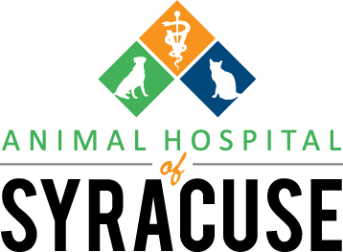

Animal Hospital Of Syracuse
9829 N SR 13
Syracuse, IN 46567
Tel: (574) 457-7144 - Fax: (574) 457-8140
ahofsyracuse.com

CLIENT AND PATIENT INFORMATION

Authorized Owner: ____________________________________ Spouse: ______________________
Address: ____________________________________City:__________________ State:__________ ZIP:_____________
Home Phone(______) - ______ - ___________
Cell Phone: (______) - ______ - ___________

Email___________________________________________________

Referred by (please “X” all that apply): ___ Phone book ___ Our Website ___ Facebook
___ Internet ___ Existing client (name): _________________________________________________
Pet’s Name: __________________________ Dog: __ Cat: ___ Other: ________________
Breed: ____________________________________ DOB: _________________ Age: ____________
Color: ____________________________________ Sex: M / F Spayed: Y / N Neutered: Y / N

Pet’s Name: __________________________ Dog: __ Cat: ___ Other: ________________
Breed: ____________________________________ DOB: _________________ Age: ____________
Color: ____________________________________ Sex: M / F Spayed: Y / N Neutered: Y / N

Pet’s Name: __________________________ Dog: __ Cat: ___ Other: ________________
Breed: ____________________________________ DOB: _________________ Age: ____________
Color: ____________________________________ Sex: M / F Spayed: Y / N Neutered: Y / N

Please provide your previous Veterinarians contact information so we can have your pet’s medical records faxed to us (vaccination information, Heart Worm testing, etc., needed).
Name: _____________________________________________ Phone: (_____) - _____ - _________
Anyone else authorized to order treatment or obtain patient information:
Name: _____________________________________________ Phone: (_____) - _____ - _________
I authorize the release of my pet’s medical records and will assume responsibility for all fees incurred:
(Signature & Date)______________________________________________________________
Note: All professional fees are due at the time services are rendered

